**Date: 16-10-21**

**Experiment 6**

**Aim:** To work with additional data types in MATLAB.

**Apparatus:** MATLAB Software

**Problems:**

**Q-1.** Write a function to_polar that accepts a complex number c, and returns two output arguments containing the magnitude mag and angle theta of the complex number. The output angle should be in degrees.

**Code:**

%clc;

%clear all;

%close all;

function Question1

c = input('\nEnter Your Complex Number: ');

[ magnitude, theta ] = to_polar(c);

fprintf("\nMagnitude: %d ",magnitude);

fprintf("\n\nAngle: %f ",theta);

end

function [ magnitude, theta ] = to_polar(c)

magnitude = abs(c);

theta = rad2deg(angle(c));

end

**Output:**

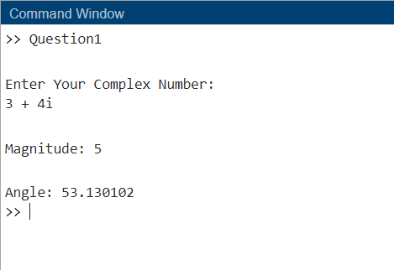

**Q-2.** Write a function to_complex that accepts two input arguments containing

the magnitude mag and angle theta of the complex number in degrees, and returns the complex number c.

**Code:**

%clc;

%clear all;

%close all;

function Question2

mag = input('\nEnter Your Magnitude: ');

theta = input('\nEnter Your Angle(Degrees): ');

[complex] = to_complex(mag, theta);

fprintf("\nMagnitude: %d ",mag);

fprintf("\n\nAngle: %3.2f \n\nComplex: ",theta);

disp(complex);

end

function [complex] = to_complex(mag, theta)

theta=theta*pi/180;

x=mag.*cos(theta);

y=mag.*sin(theta);

complex=x+ i*y;

end

**Output:**

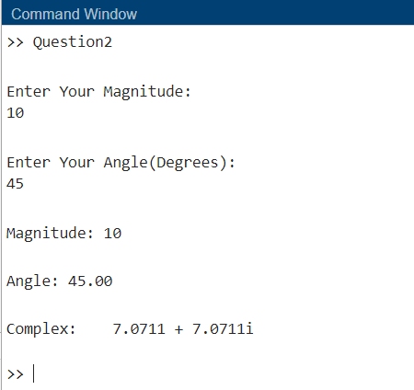

**Q-3.** In a sinusoidal steady-state AC circuit, the voltage across a passive element is given by Ohm’s Law:

V=IZ

Where, **V** is the voltage across the element, **I** is the current though the element, and ***Z*** is the impedance of the element. Note that all three of these values are complex and that these complex numbers are usually specified in the form of a magnitude at a specific phase angle expressed in degrees. For example, the voltage might be **V=**120 $∠$ 30 $°$ V.



Write a program that reads the voltage across an element and the impedance of the element, and calculates the resulting current flow. The input values should be given as magnitudes and angles expressed in degrees, and the resulting answer should be in the same form. Use the function to_complex to convert the numbers to rectangular for the actual computation of the current, and the function to_polar to convert the answer into polar form for display.

**Code:**

%clc;

%clear all;

%close all;

function Question3

mag1 = input('\nEnter Your Magnitude Of Voltage: ');

theta1 = input('\nEnter Your Angle(Degrees) of Voltage: ');

mag2 = input('\nEnter Your Magnitude Of Impedance: ');

theta2 = input('\nEnter Your Angle(Degrees) of Impedance: ');

[complex1,complex2] = to_complex(mag1, theta1 ,mag2, theta2);

[voltage,mag,theta] = to_polar(complex1,complex2);

fprintf("\nMagnitude: %3.2f ",mag);

fprintf("\n\nAngle: %3.2f \n\nVoltage: ",theta);

disp(voltage);

end

function [complex1,complex2] = to_complex(mag1, theta1 ,mag2, theta2)

theta1=theta1*pi/180;

x=mag1.*cos(theta1);

y=mag1.*sin(theta1);

complex1=x+ i*y;

theta2=theta2*pi/180;

x=mag2.*cos(theta2);

y=mag2.*sin(theta2);

complex2=x+ i*y;

end

function [ com, magnitude, theta ] = to_polar(complex1,complex2)

com = complex1./complex2;

magnitude = abs(com);

theta = rad2deg(angle(com));

end

**Output:**

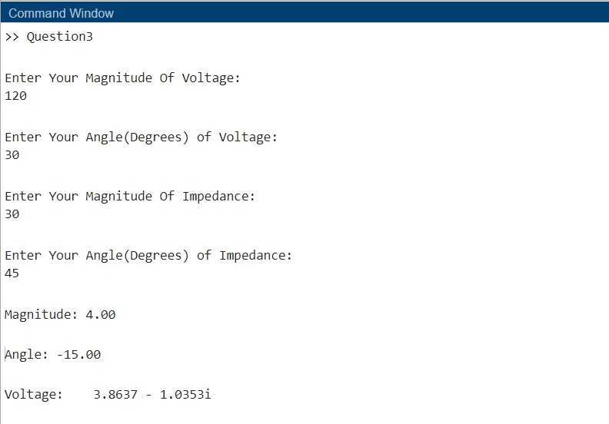

**Q-4.** Below figure shows a series *RLC* circuit driven by a sinusoidal ac voltage source whose value is 120 $∠$ 0 $°$ volts. The impedance of the inductor in this circuit is ZL=j2пfL, where *j* is $\sqrt{-1}$, ƒ is the frequency of the voltage source in hertz and *L* is the inductance in henrys. The impedance of the capacitor in this circuit is ZC=, where *C* is the capacitance in farads. Assume that R=100 $Ω, L=0.1$ mH, and C=0.25nF.

The current **I** flowing in this circuit is given by Kirchhoff ’s Voltage Law to be



(*a*) Calculate and plot the magnitude of this current as a function of frequency as the frequency changes from 100 kHz to 10 MHz. Plot this information on both a linear and a log-linear scale. Be sure to include a title and axis labels.

(*b*) Calculate and plot the phase angle in degrees of this current as a function of frequency as the frequency changes from 100 kHz to 10 MHz. Plot this information on both a linear and a log-linear scale. Be sure to include a title and axis labels.

(*c*) Plot both the magnitude and phase angle of the current as a function of frequency on two sub-plots of a single figure. Use log-linear scales.



**Code:**

%clc;

%clear all;

%close all;

function Question4

Vmag=120;

Vang=0;

R=100;

L=0.1e-3;

C=0.25e-9;

f=100e3:100e3:10e6;

w=2.*pi.*f;

Xl=w.*L;

Xc=1./(w.*C);

Z=Xl-Xc;

V=to_complex(Vmag, Vang);

I=V./(R+j*Z);

[Imag, Iang]=to_polar(I);

%a

figure(1)

plot(f, Imag,"LineStyle","--","Color","red","LineWidth",2)

title('Imag v/s f')

xlabel('Frequency')

ylabel('I Magnitude')

figure(2)

semilogx(f, Imag,"LineStyle","--","Color","blue","LineWidth",2)

title('Imag v/s f')

xlabel('Frequency')

ylabel('I Magnitude')

%b

figure(3)

plot(f, Iang,"LineStyle","-","Color","black","LineWidth",2)

title('I \theta v/s f')

xlabel('Frequency')

ylabel('I \theta')

figure(4)

semilogx(f, Iang,"LineStyle","-.","Color","cyan","LineWidth",2)

title('I \theta v/s f')

xlabel('Frequency')

ylabel('I \theta')

%c

figure(5)

subplot(2,1,1)

semilogx(f, Imag,"LineStyle","--","Color","magenta","LineWidth",2)

title('Imag v/s f')

xlabel('Frequency')

ylabel('I Magnitude')

subplot(2,1,2)

semilogx(f, Iang,"LineStyle","-","Color","black","LineWidth",2)

title('I \theta v/s f')

xlabel('Frequency')

ylabel('I \theta')

end

function [mag, theta] = to_polar(complex)

mag=abs(complex);

theta=angle(complex)*180/pi;

end

function c = to_complex(mag, theta)

theta=theta*pi/180;

[x, y] = pol2cart(theta, mag);

c=x+i*y;

end

**Output:**

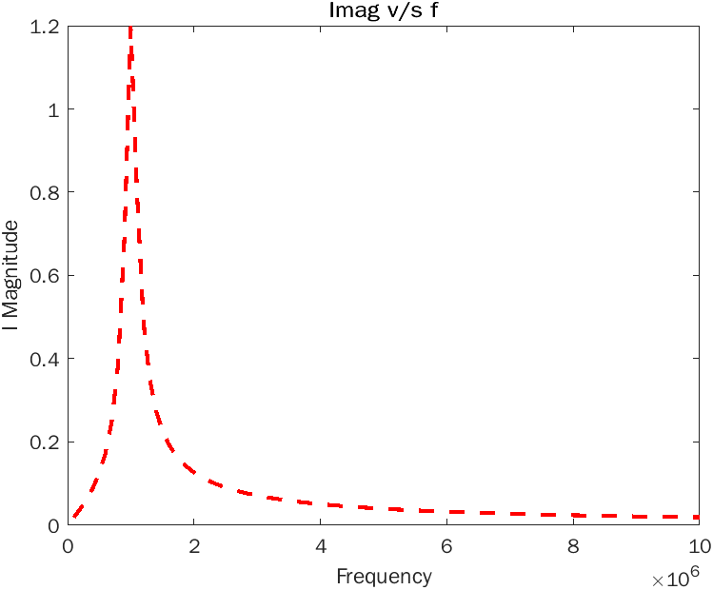

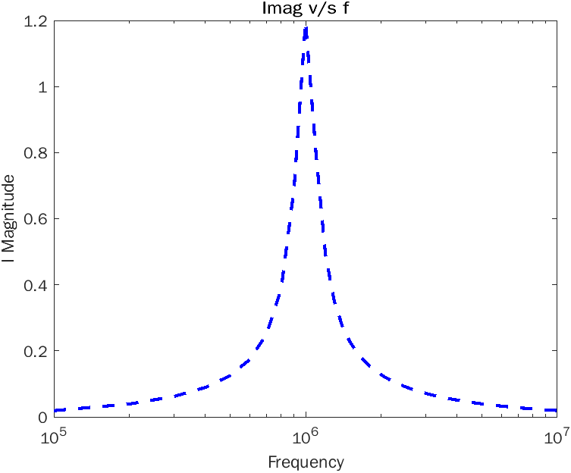

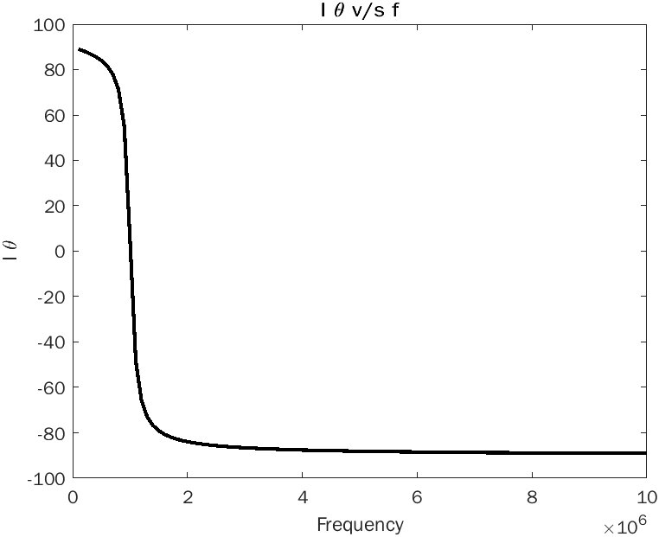

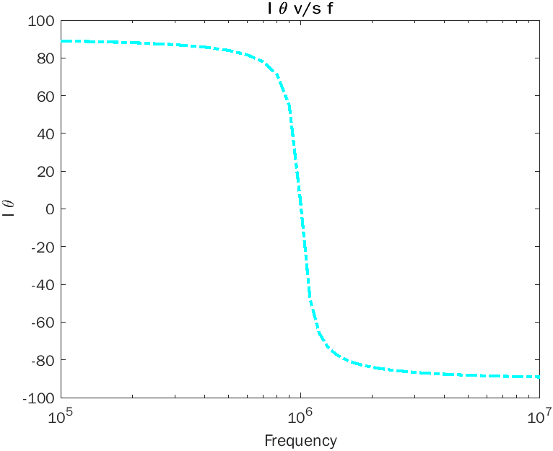

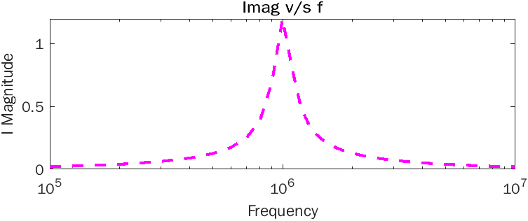

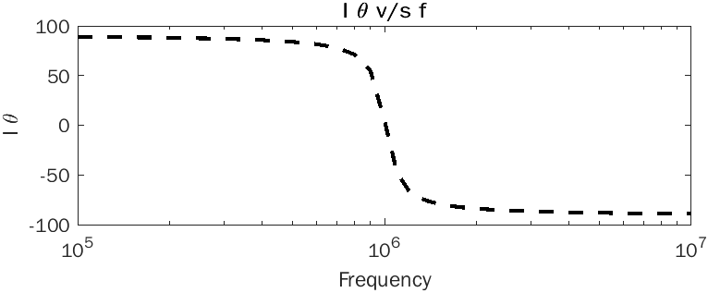

**Q-5.** Plot the function $v\left(t\right)=10e^{(-0.2+jπ)t}$ for 0 <=*t* <= 10 using the function plot(t,v). What is displayed on the plot?

**Code:**

clc;

clear all;

close all;

t=0:0.1:10;

v=10*exp((-0.2+j*pi).*t);

plot(t,v)

title('T v/s V')

xlabel('V')

ylabel('T')

**Output:**

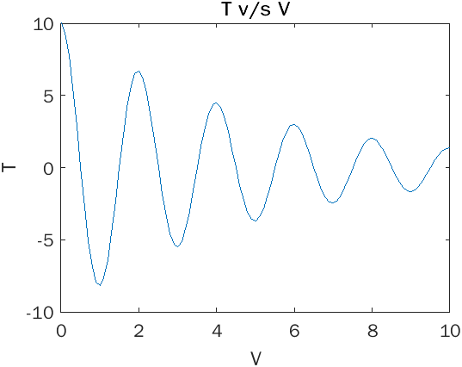

**Q-6.** Euler’s equation defines *e* raised to an imaginary power in terms of sinusoidal functions as follows:

$$e^{jθ}=cosθ+j sinθ$$

Create a two-dimensional plot of this function as $θ$ varies from 0 to 2п. Create a three-dimensional line plot using function plot3 as $θ$ varies from 0 to 2п (the three dimensions are the real part of the expression, the imaginary part of the expression, and $θ$).

**Code:**

clc;

clear all;

close all;

theta = 0:pi/100:2*pi;

e=cos(theta)+ i *sin(theta);

figure(1)

plot(theta, e)

title('e v/s \theta')

xlabel('\theta')

ylabel('e')

figure(2)

plot3(real(e), imag(e), theta,"LineStyle","--","Color","red","LineWidth",1)

title('e v/s \theta')

xlabel('Real(e)')

ylabel('Imag(e)')

zlabel('\theta')

**Output:**

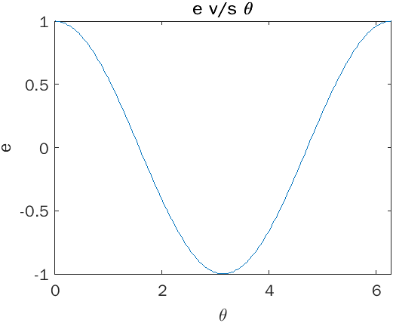

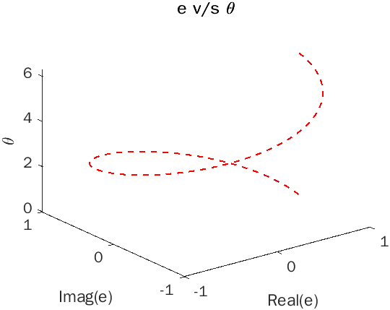

**Conclusion:**

From this experiment we came to learn different types and ways to plot graphs by using the functions and some inbuilt functions to plot 3-D graphs. Here we got acquainted with the plot functions and the theory of some of the concepts like the Euler’s Equation and Kirchhoff’s Law. We even got hands on the attributes we can use while plotting functions.